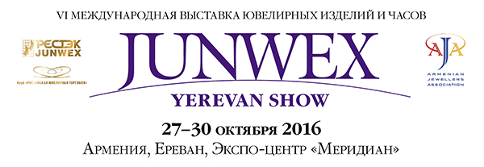
Dear Sirs,
We are pleased to invite you at the new edition of JUNWEX YEREVAN SHOW 2016, which will take place from 27 to 30 October 2016 in MERIDIAN Expocentre, Yerevan, Armenia.
Yerevan Show International Jewellery Exhibition is held by Armenian Jewelers Association (AJA) since 2011. This year show has an updated format and its name is "JUNWEX Yerevan Show", as it will be organized in partnership with the largest Russian Media-Holding "RESTEC JUNWEX".
Exhibitors from Armenia, Russia, Kazakhstan, Kyrgyzstan, Belarus, USA, Canada, France, Greece, Italy, Lebanon, Thailand, China, India, buyers from Russia, CIS, Iran as well as the leaders of the World Jewelry Community, officials, industry experts and visitors from the different countries are expected to attend the exhibition.
Armenia is the only country in the world where National Jeweller`s Day is celebrated (the last Sunday of October).
This year Yerevan Show will be at the same time with World Jewellery Confederation CIBJO Congress. Every year CIBJO Congress is being held in the different countries. In 2016, for a week (October 24 – 28) Yerevan will become the jewellery capital of the world. More than 100 key figures in the jewellery industry from around the world - delegates from 40 countries - National jewelers associations and jewelry company representatives, will get together to discuss the most important issues, which face the industry, and ways to solve them. It’s a good chance for JUNWEX Yerevan Show participants to demonstrate its jewellery and prospects for development to our colleagues from different countries.
Organizers background
- RESTEC JUNWEX is one of the most experienced trade fair organizers in Russia. Thanks to combined use of multiple media channels such as exhibitions, congresses, magazines, Internet-resources and consulting, RESTEC JUNWEX offers principally new opportunities for jewellery companies.
- RESTEC JUNWEX organizes over 9 exhibitions annually, including 3 largest international fairs: JUNWEX Petersburg (February), JUNWEX New Russian Style (May-June), JUNWEX Moscow (October).
- AJA is one of Armenia’s very first professional associations. Since its inception, its purpose has been to connect Armenian jewellers around the world and help develop the country’s jewellery industry. AJA has regional representatives in the United States, Armenia, Russia, the Middle East, Europe, South America and Australia.

Why it is important to participate in JUNWEX YEREVAN SHOW 2016?
- International representation
More than 120 exhibitors from 30 countries and regions are interested to exhibit in the JUNWEX Yerevan Show 2016
- Special Zones Sparkle
The show divides exhibitors into a number of specialized theme zones, making it easy for buyers to locate their particular niche items.
- Quality buyers
The show welcomed more than 300 buyers from 10 countries and regions, and many from top-name companies. Additional attention of wholesalers from the southern regions of Russia – Vladikavkaz, Grozny, Nalchik, Pyatigorsk, Yessentuki.
- Proud History
5 years proven record of success leads your business to reach a new heights in overseas market. Good sales on citizens of Yerevan, tourists from Iran and a wide range of the Armenians living in all regions of the world. Investigation of perspective partners for future regular deliveries and favorable purchase of diamonds in a special economic zone without customs problems.
Acquaintance with a wide range of the potential foreign partners who have arrived to Yerevan for participation in the World Congress of jewelers – CIBJO.
- Prime location
JUNWEX Yerevan Show and CIBJO Congress will be held in a unique Expocenter in the Jewellery Free Economic Zone Meridian, located in the picturesque Hrazdan gorge, just three minutes from the central square of the capital city of Armenia, well located for hotels and transport connections while incorporates a range of exceptional features geared toward the functional needs of professional exhibition.

You are cordially invited to the JUNWEX YEREVAN SHOW 2016.

